**DAY15- ASSIGNMENT**

BATCH NAME: SAP ABAP HANA

NAME: PAMPANABOINA VANDANA

EMP ID:46255266

EMP EMAIL ID: PAMPANABOINA.VANDANA@CAPGEMINI.COM

Assignment 1 – Create a Simple program to fetch data and display ALV using Std. SAP class-methods.

**Scenario** –

* Create a Custom program using ECLIPSE. Select data from table SNWD_PD.
* The output should consist three columns – Category, Max price and Average price.
* The data should consist of all categories from SNWD_PD, with maximum price for each category and average price for each category.
* There should be only 1 select statement used to achieve this using In-line Declaration, CASE, Aggregate, HAVING and GROUP BY clauses as needed.
* Selection screen can contain CATEGORY
* Output should be in ALV Grid format.

**Tables involved** – SNWD_PD / Columns – CATEGORY & PRICE

*&---------------------------------------------------------------------*

*& Report z266DAY15ALV

*&---------------------------------------------------------------------*

* Description:                                                         *

*                                                                      *

* Author:                                                              *

*                                                                      *

* Create date:                                                         *

*                                                                      *

*&---------------------------------------------------------------------*

* Modification log:                                                    *

* -------------------------------------------------------------------- *

* Date        User name      ID       Change Request   Case ref.       *

*             Description                                              *

*&---------------------------------------------------------------------*

REPORT z266DAY15ALV.

TABLES: SNWD_PD.

SELECT-OPTIONS: S_CAT FOR SNWD_PD-CATEGORY.

SELECT CATEGORY,

       MAX( PRICE ) AS MAX_PRICE,

       AVG( PRICE ) AS AVG_PRICE

       FROM SNWD_PD INTO TABLE @DATA(ITAB)

       GROUP BY CATEGORY

       HAVING CATEGORY IN @S_CAT

       ORDER BY CATEGORY.

CL_SALV_table=>factory(

  EXPORTING

    list_display   =  IF_SALV_C_BOOL_SAP=>FALSE    " ALV Displayed in List Mode

*    r_container    =     " Abstract Container for GUI Controls

*    container_name =

  IMPORTING

    r_salv_table   =   data(alv)  " Basis Class Simple ALV Tables

  CHANGING

    t_table        = itab

).

*  CATCH cx_salv_msg.

ALV->get_columns( )->get_column( columnname = 'MAX_PRICE' )->set_medium_text( value = 'Max Price' ).

*  CATCH cx_salv_not_found.    "

ALV->get_columns( )->get_column( columnname = 'AVG_PRICE' )->set_medium_text( value = 'Average Price' ).

alv->display( ).

output:

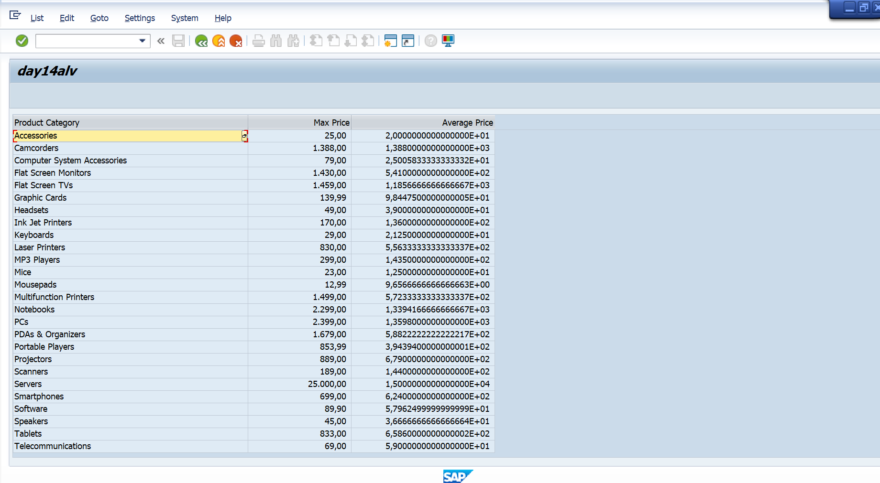

Assignment 2 – **ALV with IDA**

**Scenario:**

* Create one CDS view by selecting fields VBELN,POSNR,  VKORG, MATNR, MENGE from VBAK and VBAP table
* Perform below operations using IDA framework

1. Create select-options based on MATNR for selection screen
2. Fetch records from CDS view in ABAP program
3. Pass user input (select-option entries) to filter record accordingly
4. Hide POSNR field from display
5. Change label of VBELN as SOrder, VKORG as SOrganization, and MENGE as TotalQuantity
6. Disable standard function SORT for MATNR field
7. Hide standard toolbar FILTER
8. Set title as “ALV report with IDA, CDS consumption”
9. Enable ZEBRA pattern
10. Multiple row selection should be enabled

**Tables involved** – VBAP, VBAK

CDS VIEW:

@AbapCatalog.sqlViewName: 'ZSQL_15'

@AbapCatalog.compiler.compareFilter: true

@AbapCatalog.preserveKey: true

@AccessControl.authorizationCheck: #NOT_REQUIRED

@EndUserText.label: 'DAY15Q2'

**define** **view** z266DAY15_Q2 **as** **select** **from** vbak **as** A

**left** **outer** **join** vbap **as** B

**on** A**.**vbeln **=** B**.**vbeln **{**

      A**.**vbeln **as** Sorder**,**

B**.**posnr  **as** Sales_Document_Item**,**

A**.**vkorg  **as** Sales_Organization**,**

B**.**matnr **,**

B**.**zmeng  **as** Target_Quantity

**}**

*&---------------------------------------------------------------------*

*& Report z266day15alv

*&---------------------------------------------------------------------*

* Description: *

* *

* Author: *

* *

* Create date: *

* *

*&---------------------------------------------------------------------*

* Modification log: *

* -------------------------------------------------------------------- *

* Date User name ID Change Request Case ref. *

* Description *

*&---------------------------------------------------------------------*

REPORT z266day15alv.

TABLES: SNWD_PD.

SELECT-OPTIONS: S_CAT FOR SNWD_PD-CATEGORY.

SELECT CATEGORY,

MAX( PRICE ) AS MAX_PRICE,

AVG( PRICE ) AS AVG_PRICE

FROM SNWD_PD INTO TABLE @DATA(ITAB)

GROUP BY CATEGORY

HAVING CATEGORY IN @S_CAT

ORDER BY CATEGORY.

CL_SALV_table=>factory(

EXPORTING

list_display = IF_SALV_C_BOOL_SAP=>FALSE " ALV Displayed in List Mode

* r_container = " Abstract Container for GUI Controls

* container_name =

IMPORTING

r_salv_table = data(alv) " Basis Class Simple ALV Tables

CHANGING

t_table = itab

).

* CATCH cx_salv_msg.

ALV->get_columns( )->get_column( columnname = 'MAX_PRICE' )->set_medium_text( value = 'Max Price' ).

* CATCH cx_salv_not_found. "

ALV->get_columns( )->get_column( columnname = 'AVG_PRICE' )->set_medium_text( value = 'Average Price' ).

alv->display( ).

